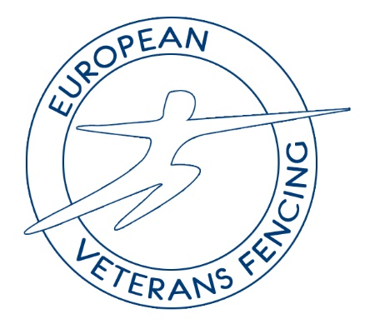
European Veterans Fencing
2026 Congress - Cognac
SECRETARY’S REPORT

This has been another busy year for veteran fencing in Europe and the number of participants in competitions is continuing to rise which is great to see.
I have continued to be the point of communication for all the European Countries dealing with correspondence and enquiries.
We now have an EVF observer at every Circuit event and we pay each €80 as an ex-gratia payment.
I maintain the contacts on the website and keep them up to date. For each congress I ensure all documents and country reports that are submitted are uploaded to the web site.
It would be good to have every member country submit a country report as it lets EVF and other countries see what is going on in the Veteran community across Europe. Those submitted for this year are linked to the member countries on the members page of the web site.
I would also appeal to all member countries to ensure I have the latest contact information for your representative.

Karen Grant
Secretary European Veterans Fencing
01/05/26

